Yes — this is the correct final access model. IT_ADMIN also gets the Own Employee Dashboard, while the special User Panel remains ROOT-only.
Role | User Panel | Own Employee Dashboard | IT / Operations | Admin Features | Approve / Deliver | User Management | System / Role Management | Delete / Override
ROOT | ✅ | ✅ | ✅ | ✅ | ✅ | ✅ | ✅ | ✅
IT_ADMIN | ❌ | ✅ | ✅ | ✅ | ✅ | ✅ | ❌ | Normal app only
IT_PERSONNEL | ❌ | ❌ | ✅ | ❌ | ✅ | ❌ | ❌ | ❌
GENERAL_USER | ❌ | ✅ Own dashboard only | ❌ | ❌ | ❌ | ❌ | ❌ | ❌

ROOT
→ Full system access
→ User Panel
→ Own Employee Dashboard
→ IT/Operations
→ Admin
→ Approval/Delivery
→ User Management
→ System/Role Management
→ Delete/Override

IT_ADMIN
→ Own Employee Dashboard
→ IT/Operations
→ Admin
→ Approval/Delivery
→ User Management
→ No ROOT User Panel
→ No System/Role Management

IT_PERSONNEL
→ IT/Operations
→ Approval/Delivery only

GENERAL_USER
→ Own Employee Dashboard only

I recommend these permissions:
ROOT
--------------------------------
panel.root.access
panel.user.access
dashboard.self.access
panel.staff.access
panel.admin.access
requisition.view
requisition.approve
requisition.deliver
users.view
users.manage
audit.view
roles.manage
system.manage
records.delete
records.override

IT_ADMIN
--------------------------------
dashboard.self.access
panel.staff.access
panel.admin.access
requisition.view
requisition.approve
requisition.deliver
users.view
users.manage
audit.view

IT_PERSONNEL
--------------------------------
panel.staff.access
requisition.view
requisition.approve
requisition.deliver

GENERAL_USER
--------------------------------
dashboard.self.access
The routing should then be:
ROOT
→ /dashboard
→ /dashboard/user Own Employee Dashboard
→ /dashboard/user-panel ROOT-only User Panel

IT_ADMIN
→ /dashboard
→ /dashboard/user Own Employee Dashboard

IT_PERSONNEL
→ /dashboard

GENERAL_USER
→ /dashboard/user
For the Own Employee Dashboard:
ROOT / IT_ADMIN / GENERAL_USER
--------------------------------
Top Bar
├── Dashboard
├── Create TT
└── Logout

Body
├── Employee Information
├── Total TT
├── Open TT
├── Running TT
├── Closed TT
└── My Trouble Ticket Table
For GENERAL_USER, this is their only application dashboard. No sidebar, no right sidebar, no Inventory, no Operations, no Admin, no Approval/Delivery.
For IT_ADMIN, they can move between:
Main IT/Admin Dashboard
↕
Own Employee Dashboard
For ROOT, they can access all three areas:
Main System Dashboard
Own Employee Dashboard
ROOT-only User Panel
Next implementation order
We should now stop changing the model and implement this exact one:
1. PostgreSQL permissions ← NEXT
2. frontend/lib/api.ts
3. Backend Own Employee Dashboard API
4. frontend/app/dashboard/user/page.tsx
5. frontend/app/auth/page.tsx
6. frontend/app/dashboard/layout.tsx
7. frontend/components/ui/header.tsx
8. frontend/components/ui/sidebar.tsx
9. ROOT-only User Panel
10. Direct URL protection
11. Test ROOT / IT_ADMIN / IT_PERSONNEL / GENERAL_USER
The next step is PostgreSQL. We should create dashboard.self.access and panel.staff.access, then assign the permissions according to this final table.

Good — this result confirms the database is still on the old permission model. In particular, IT_PERSONNEL and GENERAL_USER still have panel.user.access, and GENERAL_USER still has requisition.view. The two new permissions do not exist yet.
Do not delete or change any existing permissions yet. First we’ll confirm the exact auth_permissions table structure so I can give you one safe transaction without guessing column names.
Step 1 — Check auth_permissions structure
In the same pgAdmin Query Tool, run:
SELECT
column_name,
data_type,
is_nullable,
column_default
FROM information_schema.columns
WHERE table_schema = 'public'
AND table_name = 'auth_permissions'
ORDER BY ordinal_position;
Then run:
SELECT
indexname,
indexdef
FROM pg_indexes
WHERE schemaname = 'public'
AND tablename IN (
'auth_permissions',
'auth_role_permissions'
)
ORDER BY tablename, indexname;
Send me the result of those two queries.
After that, I’ll give you one complete SQL transaction that safely changes the current 24 rows into this final model:
ROOT
→ Full system access
→ User Panel
→ Own Employee Dashboard
→ IT/Operations
→ Admin
→ Approval/Delivery
→ User Management
→ System/Role Management
→ Delete/Override

IT_ADMIN
→ Own Employee Dashboard
→ IT/Operations
→ Admin
→ Approval/Delivery
→ User Management
→ No ROOT User Panel
→ No System/Role Management

IT_PERSONNEL
→ IT/Operations
→ Approval/Delivery only

GENERAL_USER
→ Own Employee Dashboard only
Then, once PostgreSQL is verified, the next file will be:
frontend/lib/api.ts
where we’ll add:
"panel.staff.access"
"dashboard.self.access"
plus canAccessStaffPanel() and canAccessOwnDashboard(). Your current centralized permission helper structure is already the right place for that.

SELECT
r.id AS role_id,
r.code AS role_code,
r.name AS role_name,
p.code AS permission_code
FROM public.auth_role_permissions rp
JOIN public.auth_roles r
ON r.id = rp.role_id
JOIN public.auth_permissions p
ON p.id = rp.permission_id
WHERE r.code IN (
'ROOT',
'IT_ADMIN',
'IT_PERSONNEL',
'GENERAL_USER'
)
ORDER BY
CASE r.code
WHEN 'ROOT' THEN 1
WHEN 'IT_ADMIN' THEN 2
WHEN 'IT_PERSONNEL' THEN 3
WHEN 'GENERAL_USER' THEN 4
ELSE 5
END,
p.code;

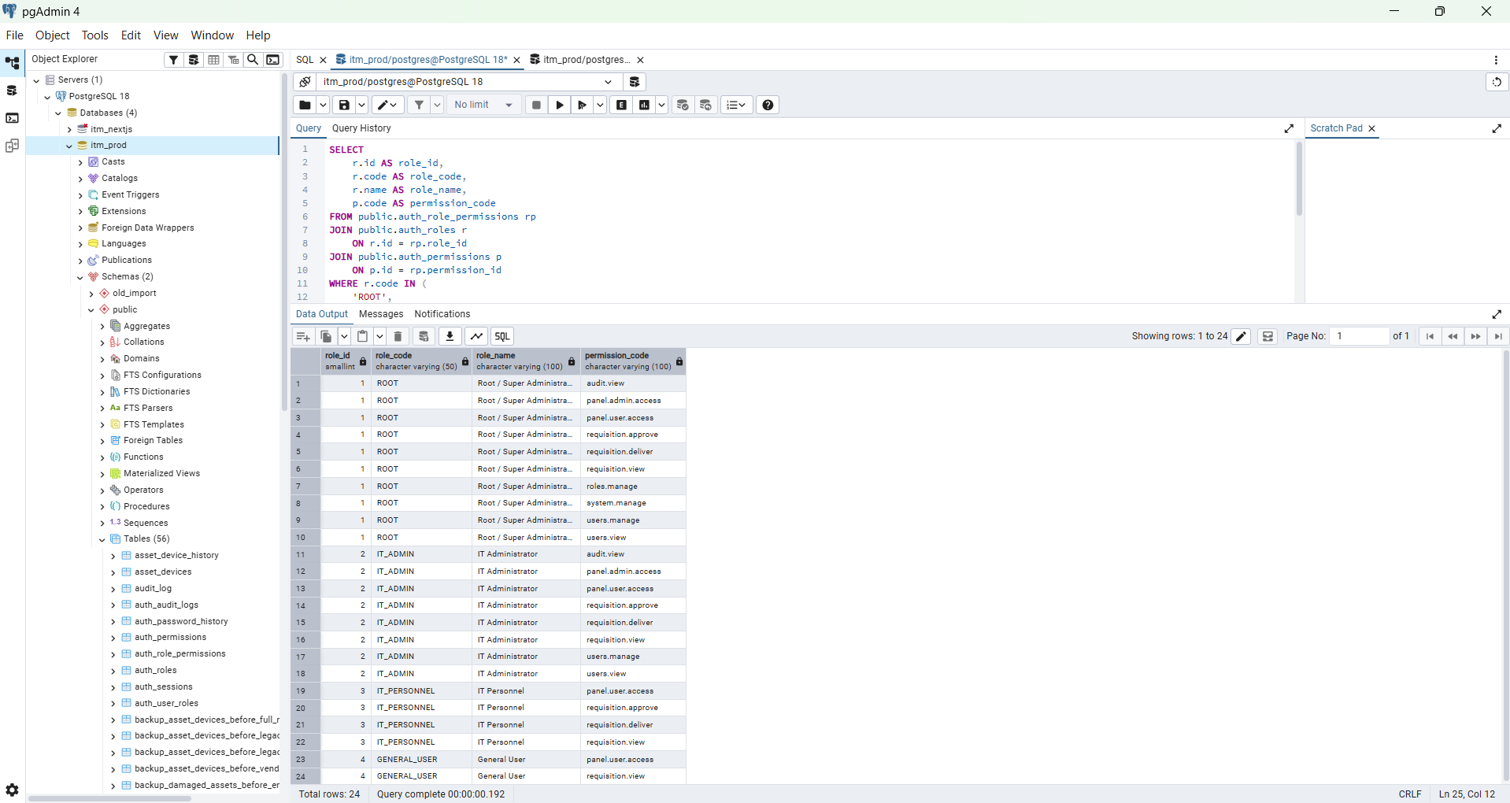

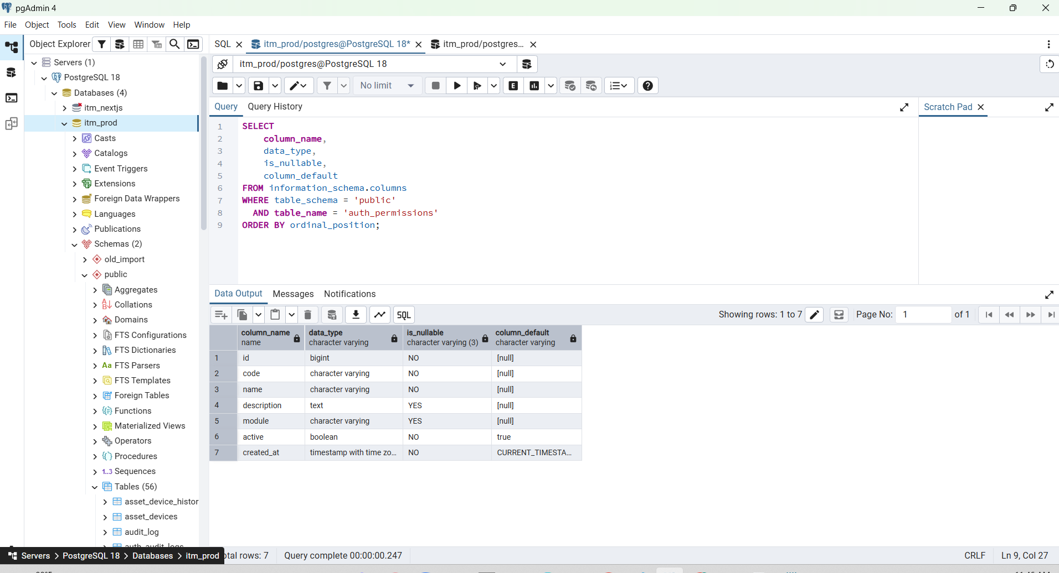

SELECT
column_name,
data_type,
is_nullable,
column_default
FROM information_schema.columns
WHERE table_schema = 'public'
AND table_name = 'auth_permissions'
ORDER BY ordinal_position;

SELECT
indexname,
indexdef
FROM pg_indexes
WHERE schemaname = 'public'
AND tablename IN (
'auth_permissions',
'auth_role_permissions'
)
ORDER BY tablename, indexname;

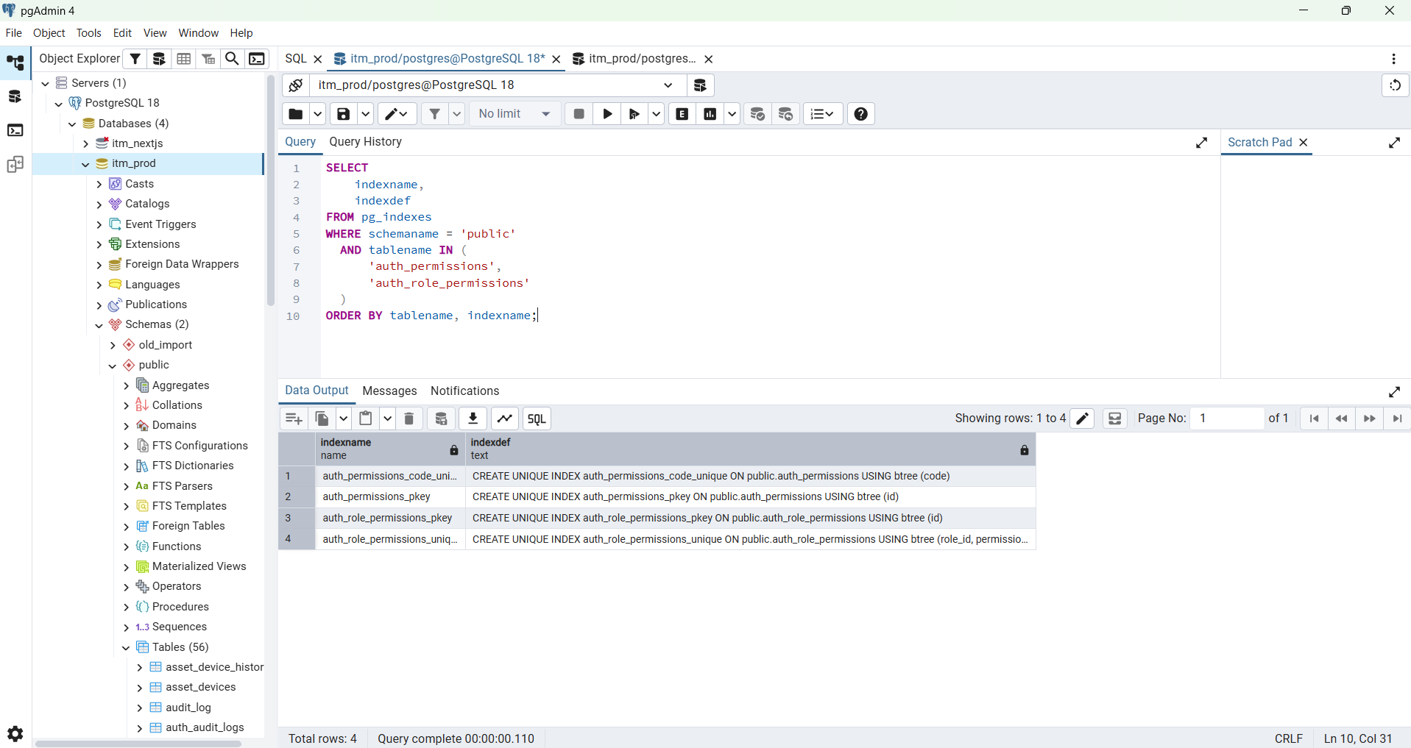

SELECT
column_name,
data_type,
is_nullable,
column_default
FROM information_schema.columns
WHERE table_schema = 'public'
AND table_name = 'auth_role_permissions'
ORDER BY ordinal_position;

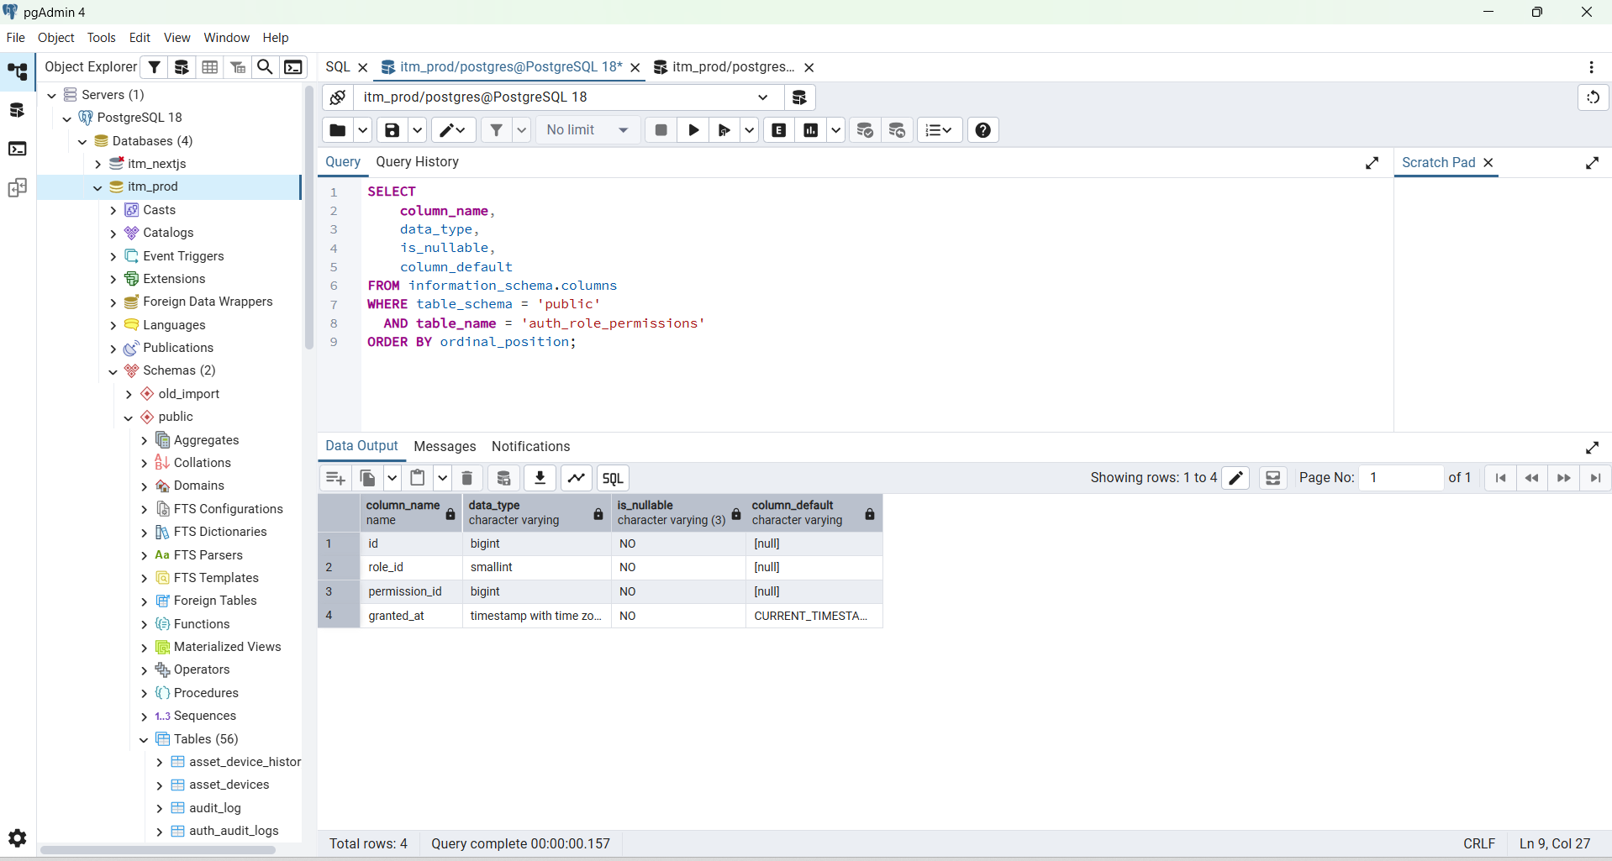

SELECT
id,
code,
name,
module,
active
FROM public.auth_permissions
ORDER BY id;

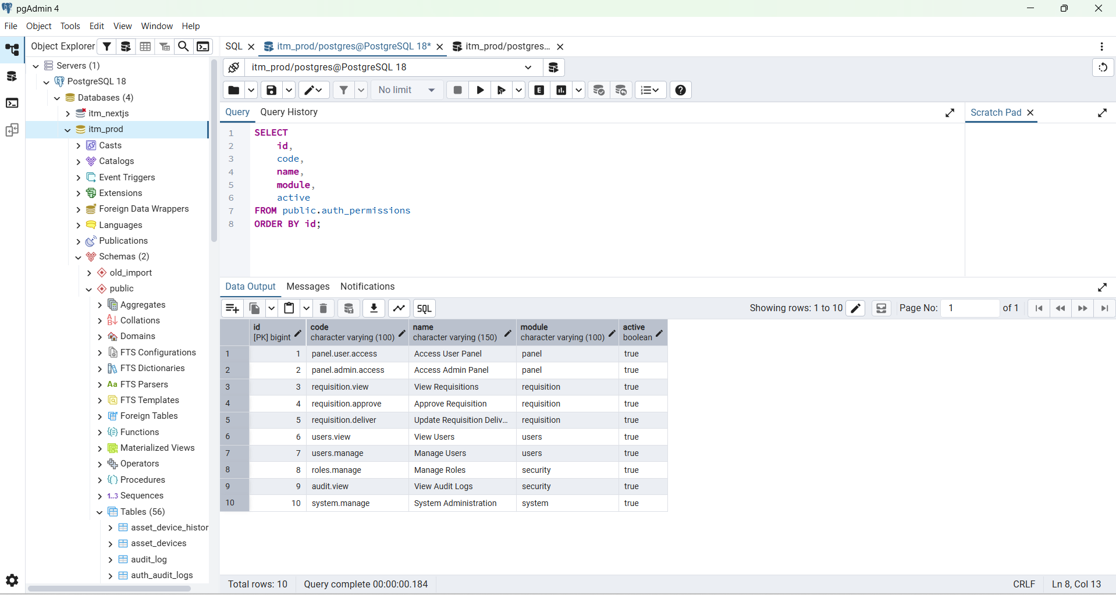

SELECT
(SELECT COALESCE(MAX(id), 0) FROM public.auth_permissions)
AS max_permission_id,

(SELECT COALESCE(MAX(id), 0) FROM public.auth_role_permissions)
AS max_role_permission_id;

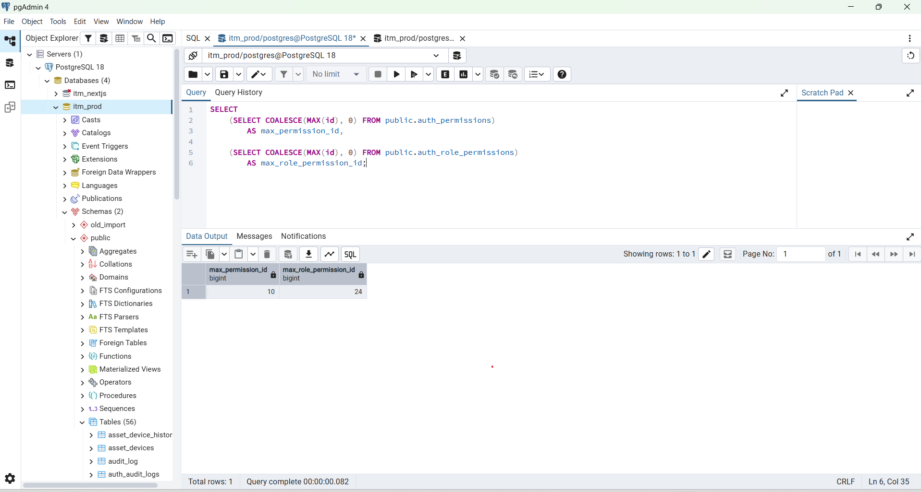

SELECT
r.id AS role_id,
r.code AS role_code,
r.name AS role_name,
p.code AS permission_code
FROM public.auth_role_permissions rp
JOIN public.auth_roles r
ON r.id = rp.role_id
JOIN public.auth_permissions p
ON p.id = rp.permission_id
WHERE r.code IN (
'ROOT',
'IT_ADMIN',
'IT_PERSONNEL',
'GENERAL_USER'
)
ORDER BY
CASE r.code
WHEN 'ROOT' THEN 1
WHEN 'IT_ADMIN' THEN 2
WHEN 'IT_PERSONNEL' THEN 3
WHEN 'GENERAL_USER' THEN 4
ELSE 5
END,
p.code;

Expected:
ROOT
audit.view
dashboard.self.access
panel.admin.access
panel.staff.access
panel.user.access
requisition.approve
requisition.deliver
requisition.view
roles.manage
system.manage
users.manage
users.view

IT_ADMIN
audit.view
dashboard.self.access
panel.admin.access
panel.staff.access
requisition.approve
requisition.deliver
requisition.view
users.manage
users.view

IT_PERSONNEL
panel.staff.access
requisition.approve
requisition.deliver
requisition.view

GENERAL_USER
dashboard.self.access

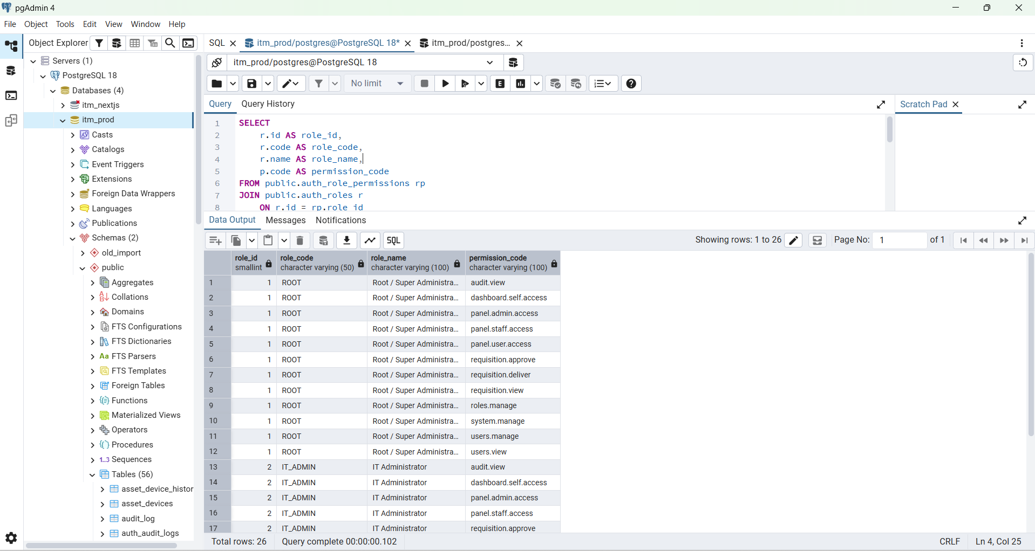

SELECT
r.code AS role_code,
COUNT(*) AS permission_count
FROM public.auth_role_permissions rp
JOIN public.auth_roles r
ON r.id = rp.role_id
WHERE r.code IN (
'ROOT',
'IT_ADMIN',
'IT_PERSONNEL',
'GENERAL_USER'
)
GROUP BY r.code
ORDER BY
CASE r.code
WHEN 'ROOT' THEN 1
WHEN 'IT_ADMIN' THEN 2
WHEN 'IT_PERSONNEL' THEN 3
WHEN 'GENERAL_USER' THEN 4
ELSE 5
END;

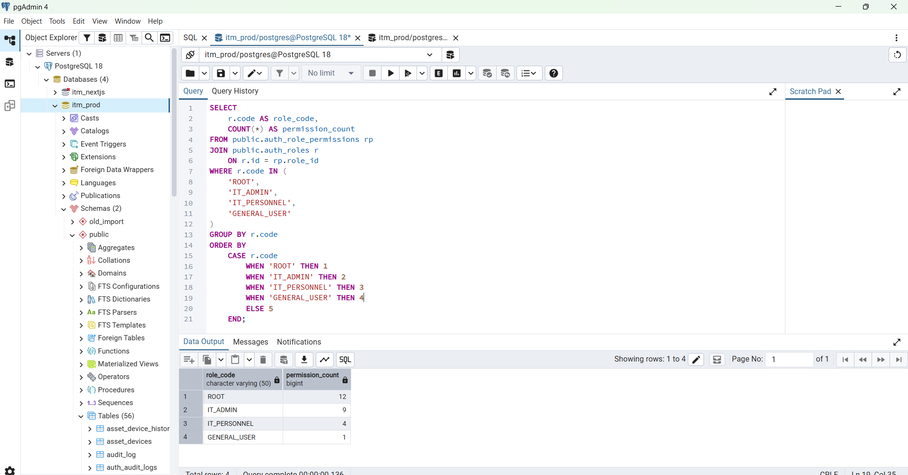

Expected:
ROOT 12
IT_ADMIN 9
IT_PERSONNEL 4
GENERAL_USER 1

The meanings are now:
panel.user.access
→ ROOT-only User Panel

dashboard.self.access
→ Own Employee Dashboard
ROOT + IT_ADMIN + GENERAL_USER

panel.staff.access
→ Inventory + Operations
ROOT + IT_ADMIN + IT_PERSONNEL

panel.admin.access
→ Admin Features
ROOT + IT_ADMIN

Your API is working correctly now. The reason you see empty employee fields and 0 tickets is simply that you are logged in as the test ROOT account:
employee_id = ROOT-001
That ID is not a real employee ID in your employee master or Trouble Ticket data. Your backend already resolves the employee ID from the authenticated session, which is the correct security design. Employee profile data comes from employee_office_info joined with employee_personal_info, so once the login account contains a real employee ID, the same API will return the real name, department, designation, phone, email, etc.
I also checked your uploaded legacy tbl_user_info Excel. It contains about 2,676 user records and includes the important columns:
user_name
password
employee_id
email
mobile
user_type
full_name
status
active
The sample records use real employee IDs such as:
02-2900
02-2898
02-2897
...
That is exactly what we need.
How dashboard.self.access works
Do not add dashboard.self.access separately to every user.
The flow is:
User
↓
Role
↓
Role permissions
↓
dashboard.self.access
You already configured:
ROOT
→ dashboard.self.access ✅

IT_ADMIN
→ dashboard.self.access ✅

GENERAL_USER
→ dashboard.self.access ✅

IT_PERSONNEL
→ dashboard.self.access ❌
So for a legacy user with:
user_type = 3
the migration should assign:
GENERAL_USER
and that role automatically gives:
dashboard.self.access
Your existing role constants also define 0=ROOT, 1=IT_ADMIN, 2=IT_PERSONNEL, 3=GENERAL_USER.
The login flow becomes:
Legacy real user
employee_id = 02-xxxx
↓
auth_users
↓
auth_user_roles
↓
GENERAL_USER
↓
dashboard.self.access
↓
JWT contains employee_id = 02-xxxx
↓
GET /user/dashboard
↓
employee_office_info
↓
real employee profile

GET /user/trouble-tickets
↓
trouble_tickets.employee_id = 02-xxxx
↓
only that employee's tickets
Your Trouble Ticket data is already indexed/structured around employee_id, so this is the correct connection key.
Next step — migrate ONE real user first
Do not migrate all 2,676 users immediately. First test one real GENERAL_USER end-to-end.
For example, choose one real employee ID from your Excel, such as:
02-2900
First verify that employee exists in PostgreSQL:
SELECT
o.employee_id,
o.employee_name,
o.designation,
o.department_name,
o.work_field,
o.sub_function,
o.active,
p.personal_cell_no,
p.official_cell_no,
p.email,
p.official_email
FROM public.employee_office_info o
LEFT JOIN public.employee_personal_info p
ON p.employee_id = o.employee_id
WHERE BTRIM(o.employee_id) = '02-2900';
Then check their Trouble Tickets:
SELECT
COUNT(*) AS total_tickets
FROM public.trouble_tickets
WHERE BTRIM(COALESCE(employee_id, '')) = '02-2900';
If both work, then that employee is a perfect pilot user.
Very important about the legacy password
Your legacy Excel contains a password column, and the sample data appears to contain readable/plain-text passwords.
Do not copy that value directly into the new auth password field.
Your new authentication already expects bcrypt password hashes.
So migration must do one of these:
Option A — recommended
Legacy password
↓
bcrypt hash
↓
auth_users.password_hash

Option B — safer for production
Create migrated account
↓
temporary/reset password
↓
must_change_password = true
I prefer Option B for production, especially because the legacy passwords were stored in readable form.
Before I give you the migration SQL/code
We need the exact current structure of your new authentication tables. Otherwise I would be guessing column names.
In pgAdmin run these four queries.
SELECT
table_name
FROM information_schema.tables
WHERE table_schema = 'public'
AND table_name LIKE 'auth_%'
ORDER BY table_name;
Then:
SELECT
column_name,
data_type,
is_nullable,
column_default
FROM information_schema.columns
WHERE table_schema = 'public'
AND table_name = 'auth_users'
ORDER BY ordinal_position;
Then:
SELECT
column_name,
data_type,
is_nullable,
column_default
FROM information_schema.columns
WHERE table_schema = 'public'
AND table_name = 'auth_user_roles'
ORDER BY ordinal_position;
And:
SELECT *
FROM public.auth_roles
ORDER BY id;
Send me those results.
Then I will give you the next exact step:
1. Migrate one real GENERAL_USER from tbl_user_info
2. Hash/set password correctly
3. Assign GENERAL_USER role
4. Confirm /auth/me contains dashboard.self.access
5. Login with that real account
6. GET /user/dashboard → real employee information
7. GET /user/trouble-tickets → real employee tickets
8. After pilot passes, bulk migrate all legacy users
Once that one real user works, your General User dashboard will be connected to actual production employee and TT data instead of the temporary ROOT-001 test data.

SELECT
BTRIM(t.employee_id) AS employee_id,
COUNT(*) AS total_tickets
FROM public.trouble_tickets t
WHERE NULLIF(
BTRIM(
COALESCE(t.employee_id, '')
),
''
) IS NOT NULL
GROUP BY
BTRIM(t.employee_id)
ORDER BY
COUNT(*) DESC
LIMIT 20;

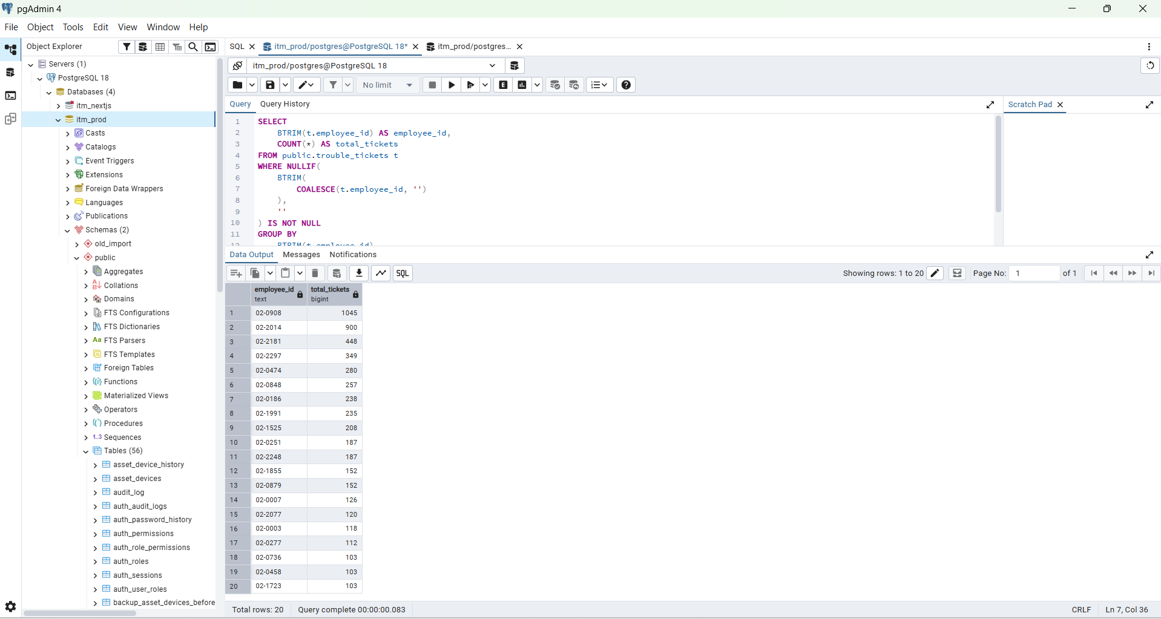

SELECT
o.employee_id,
o.employee_name,
o.designation,
o.department_name,
o.work_field,
o.sub_function,
o.active,
p.personal_cell_no,
p.official_cell_no,
p.email,
p.official_email,
p.picture
FROM public.employee_office_info o
LEFT JOIN public.employee_personal_info p
ON BTRIM(p.employee_id) =
BTRIM(o.employee_id)
WHERE BTRIM(o.employee_id) = '02-0908';

--------------------------------------------------------------------------------------------
Postman Result
Method : GET
http://127.0.0.1:8080/api/v1/auth/me
{
"data": {
"account_status": "active",
"email": "test.general@itm.local",
"employee_id": "02-0908",
"full_name": "Test General User",
"must_change_password": true,
"permissions": [
"dashboard.self.access"
],
"role_code": "GENERAL_USER",
"role_name": "General User",
"user_id": 4,
"user_type": 3,
"username": "test.general"
},
"success": true
}

